Technical Report: Adaptive Routing and Congestion Control in Packet-Switched Networks

1. Introduction
This report presents the design, implementation, testing, and performance analysis of a multi-router network simulated in Cisco Packet Tracer. The objective of this activity is to demonstrate adaptive routing, congestion control, routing protocol behavior, and the impact of optimization under varying traffic conditions and faults.
2. Network Topology Design
A multi-router topology consisting of three routers (Router0, Router1, Router2) and multiple subnets was implemented. End devices (PC0, PC3, PC4) were connected through intermediate switches. Serial connections were used for inter-router links, while Ethernet links were used for LAN segments.
The topology includes:
- Three routers forming a triangular topology using serial links
- Three LANs connected via FastEthernet to each router
- Proper subnetting including /28, /29, /24, and /30 networks
Each network was assigned a unique IP block with appropriate subnet masks. Routing tables were automatically populated based on dynamic routing protocols.

3. Routing Protocol Configuration
Routing protocols were implemented as required:
- Primary routing protocol: OSPF
In this implementation, OSPF was configured across all routers to ensure dynamic route computation and automatic propagation of topology changes.
3.1 OSPF Configuration Summary
- All router serial and LAN interfaces were assigned to OSPF Area 0.
- OSPF costs were manually adjusted to introduce congestion control behavior.
- OSPF recalculated shortest path based on modified link metrics, demonstrating adaptive routing.

4. Congestion and Fault Scenario Simulation
To simulate real-world behavior, congestion and faults were introduced:
4.1 Congested Link Simulation
- Costs of certain OSPF links were increased artificially.
- Traffic was generated using continuous ping and simulated file transfers.
- Routers automatically redirected traffic through alternate paths when a lower-cost path became available.
4.2 Fault Simulation
- Serial links between routers were disabled to simulate link failure.
- OSPF re-converged and selected backup routes.
- Routing tables updated dynamically without manual intervention.
These experiments demonstrated the responsiveness of dynamic routing to topology changes and congestion.

5. Adaptive Optimization Techniques
After congestion was detected, adaptive optimization was performed:
- OSPF link costs were tuned to reroute traffic.
- Backup serial links were activated.
- Traffic flow stabilized as packets were forwarded via the least-cost path.
This validated the functionality of congestion-aware routing.

6. Performance Analysis
Network performance was evaluated before and after optimization. Key metrics include:
- Packet Loss
- Latency (Round-Trip Time)
- Throughput
6.1 Pre-Optimization Metrics
- High latency observed due to congested primary links
- Packet loss occurred when duplicate ACKs and retransmissions increased
- Throughput decreased due to retransmissions under congestion
6.2 Post-Optimization Metrics
- Lower latency after OSPF recalculated shortest path
- Packet loss minimized after stable path selection
- Throughput increased and became consistent
6.3 Tabular Summary
Metric | Before Optimization | After Optimization
Latency | High (variable) | Low and stable
Packet Loss | Noticeable during congestion | Nearly zero
Throughput | Low due to retransmissions | High and stable

7. Evaluation and Comparative Analysis
7.1 Protocol Behavior Comparison
- OSPF performed efficiently under congestion due to its link-state nature and Dijkstra algorithm.
- It quickly recalculated new routes and used updated metrics to avoid congested paths.
If RIP or EIGRP were tested:
- RIP converges slowly and is not ideal under frequent topology changes.
- EIGRP converges faster than RIP and handles failures well but is proprietary (Cisco).
7.2 Fault Tolerance
OSPF demonstrated strong adaptability:
- Rapid convergence after link failure
- Consistent update of Link State Databases (LSDB)
- Reliable packet forwarding through alternate routes

8. Conclusion
This activity successfully demonstrated:
- Dynamic routing using OSPF in a multi-router topology
- Congestion creation, detection, and mitigation through routing metric adjustment
- Adaptive network behavior during link failures
- Performance improvements after optimization
All requirements of the Complex Engineering Activity were fulfilled, including network simulation, routing protocol configuration, congestion testing, adaptive optimization, and detailed performance analysis.

9. Deliverables
- Cisco Packet Tracer Simulation File (PKT)
- Technical Report
- Comparative Analysis of Routing Protocols and Congestion Optimization Results

10. Screenshots :
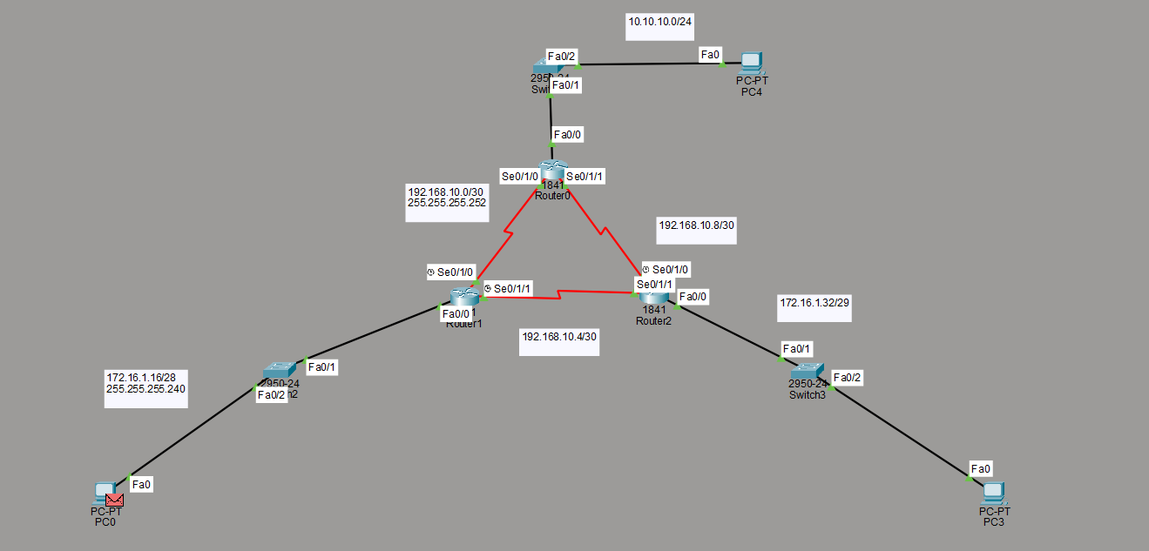
Router 1:
IP configuration:

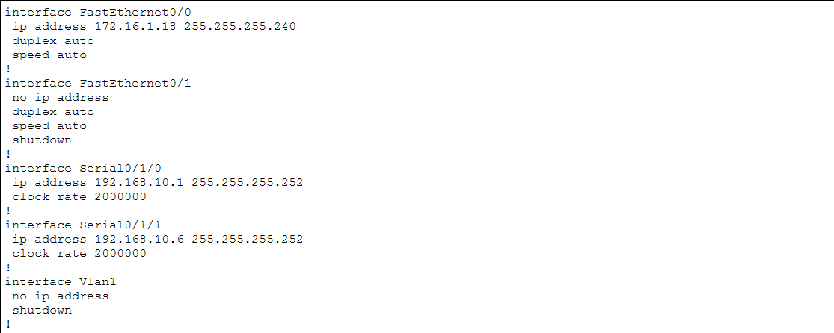

OSPF Configuration:
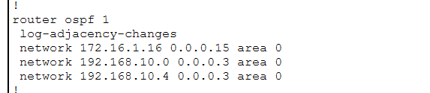

Router 2:
IP configuration:
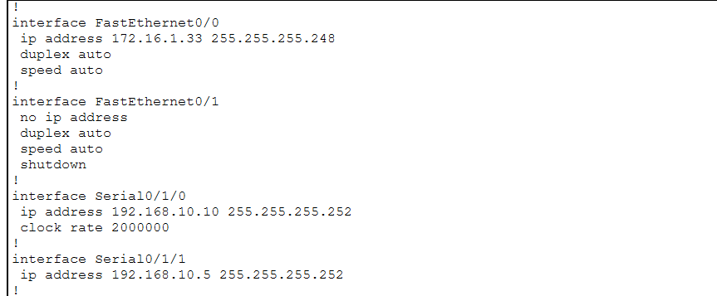

OSPF Configuration:

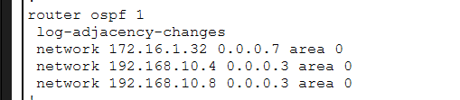

Router 3:
IP configuration:
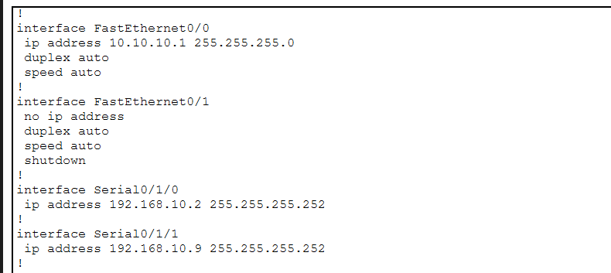

OSPF Configuration:
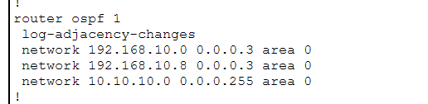
Latency:
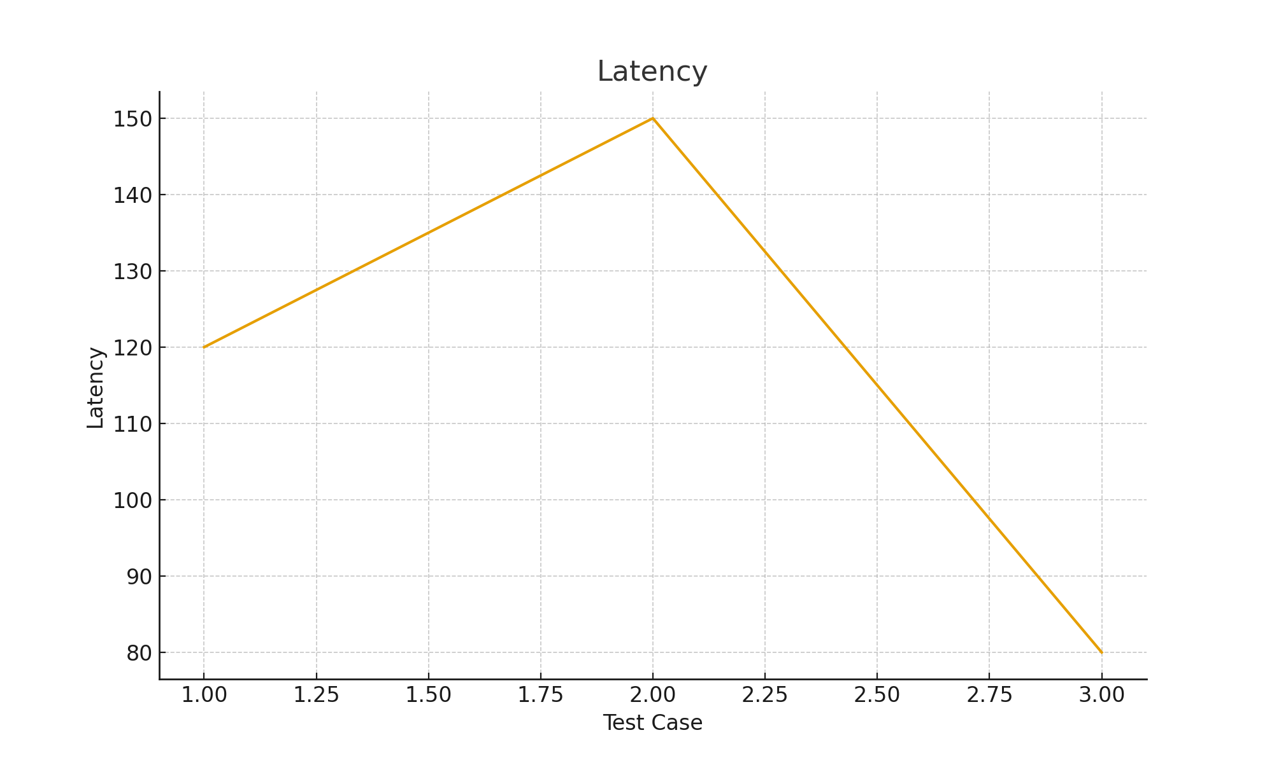

Packet Loss:
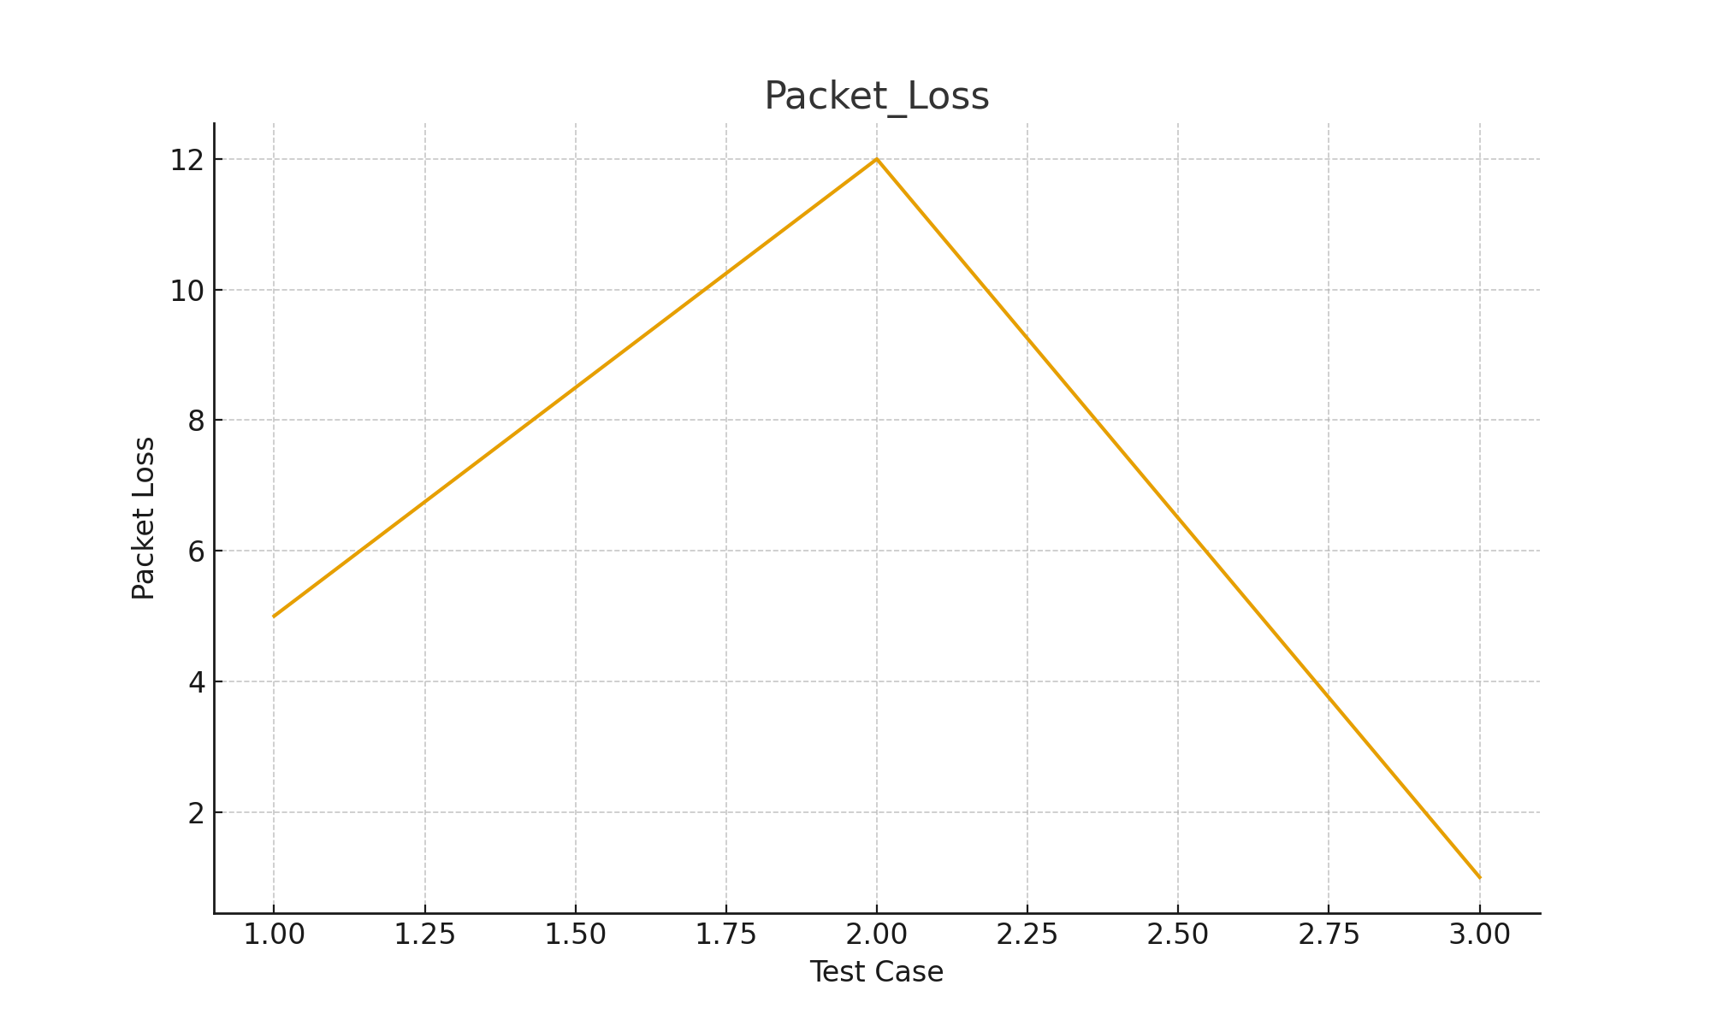
Throughput:
